**Solution Description: -**

1. I have converted the Bool type categorical columns to their numeric forms.
2. As there are many null values in different types of numerical columns. So, I have imputed them by using the strategy as mean.
3. The 0/1 class distribution ratio was 44%.
4. I have chosen many models for the modelling part. Please find below the detailed explanation: -
   1. **Decision Tree: -**
      1. A decision tree typically starts with a single node, which branches into possible outcomes.
      2. Each of those outcomes lead to additional nodes, which branch off into other possibilities.
      3. This gives it a tree like shape.

By Training the Decision Tree the following roc_auc_score on train and test set was obtained: -



* 1. **Random Forest: -**
     1. It consists of many individual decision trees that operates as an ensemble.
     2. Each individual tree in the random forest spits out a class prediction and the class with the most votes become our model’s prediction.

By Training the Random Forest model the following roc_auc_score was obtained on the train and test dataset: -



* 1. **XGBoost: -**
     1. It stands for extreme gradient boosting.
     2. In this algorithm, decision trees are created in the sequential form.
     3. Weights are assigned to all the independent variables which are then fed into the decision tree which predicts the results.

By Training the XGBoost model the following roc_auc_score was obtained: -

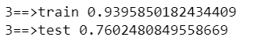

* 1. **LightGBM: -**
     1. It is a gradient boosting framework that uses tree based learning algorithm.

By Training the LGBM model the following roc_auc_score was obtained: -

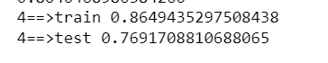

The Final was used is XGBOOST MODEL as after tuning we are getting the best roc_auc_score. The following are the parameters that are used in the final model: -

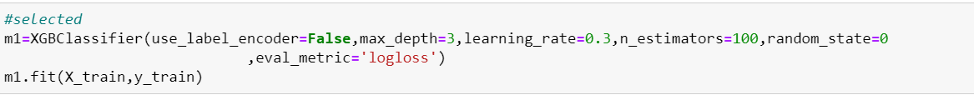

**The following is the importance of all the different variables: -**

